
PROBLEM STATEMENT

Day 81 : Dff8r
Day 82 : Dff8p
Day 83 : Dff8ar
Day 84 : Dff16e
Day 85: Exams/m2014 q4a
Day 86 : Exams/m2014 q4b
Day 87 : Exams/m2014 q4c
Day 88 : Exams/m2014 q4d
Day 89 : Mt2015 muxdff
Day 90: Exams/2014 q4a

DAY:81 Dff8r
Problem Statement:
Module Declaration:
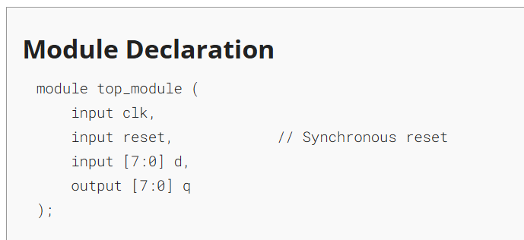
Solution:
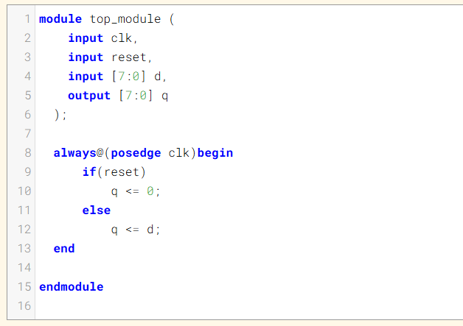
Code:
module top_module (
input clk,
input reset,
input [7:0] d,
output [7:0] q
);
always@(posedge clk)begin
if(reset)
q <= 0;
else
q <= d;
end
endmodule

Timing Diagram:
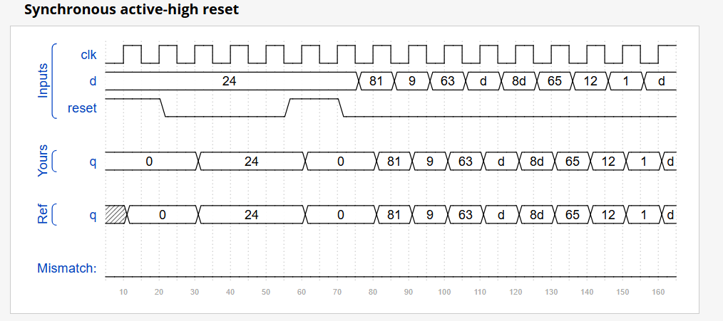
DAY:82 Dff8p
Problem Statement:
Module Declaration:
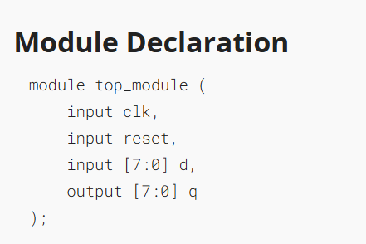

Solution:
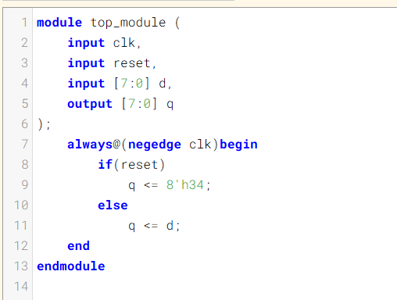
Code:
module top_module (
input clk,
input reset,
input [7:0] d,
output [7:0] q
);
always@(negedge clk)begin
if(reset)
q <= 8'h34;
else
q <= d;
end
endmodule
Timing Diagram:
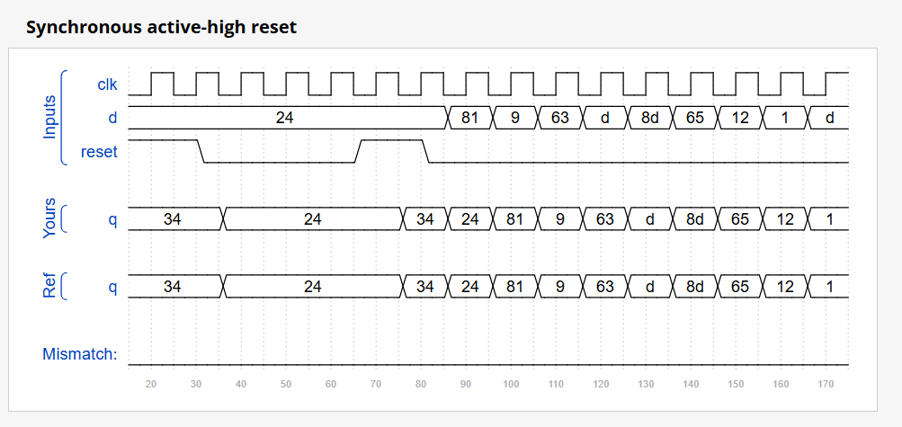
DAY:83 Dff8ar
Problem Statement:
Module Declaration:
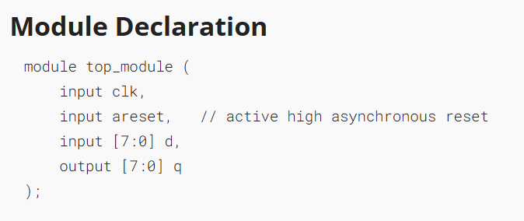
Solution:
module top_module (
input clk,
input areset,
input [7:0] d,
output [7:0] q
);
always@(posedge clk,posedge areset)begin
if(areset)
q <= 0;
else
q <= d;
end

endmodule
Timing Diagram:
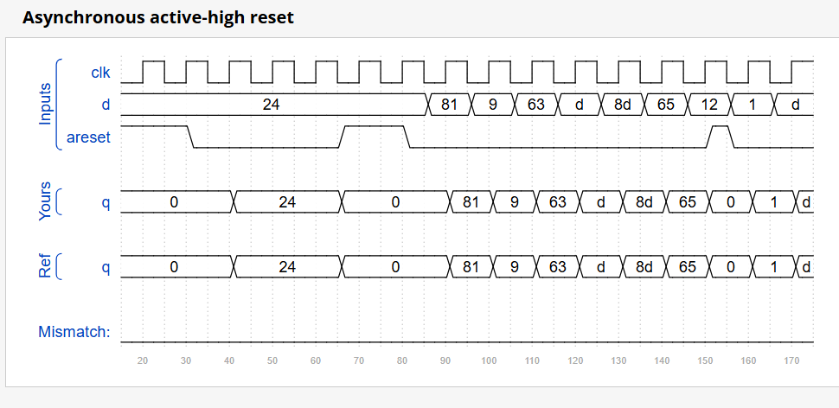
DAY:84 Dff16e
Problem Statement:
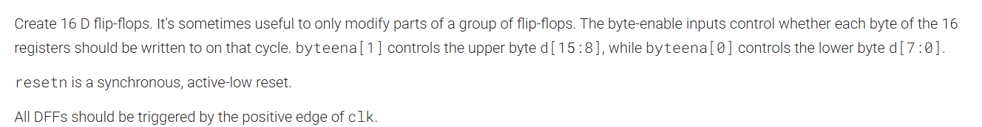
Module Declaration:
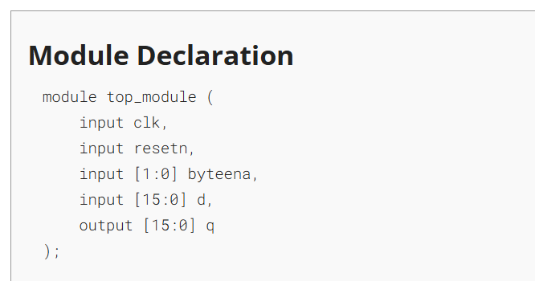

Solution:
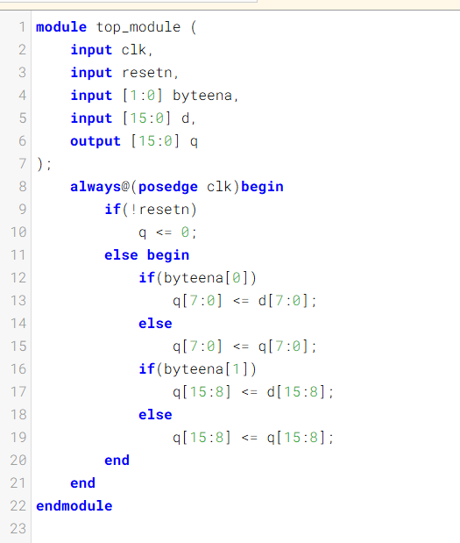
Code:
module top_module (
input clk,
input resetn,
input [1:0] byteena,
input [15:0] d,
output [15:0] q
);
always@(posedge clk)begin
if(!resetn)
q <= 0;
else begin
if(byteena[0])
q[7:0] <= d[7:0];
else
q[7:0] <= q[7:0];
if(byteena[1])
q[15:8] <= d[15:8];
else
q[15:8] <= q[15:8];
end
end
endmodule

Timing Diagram:
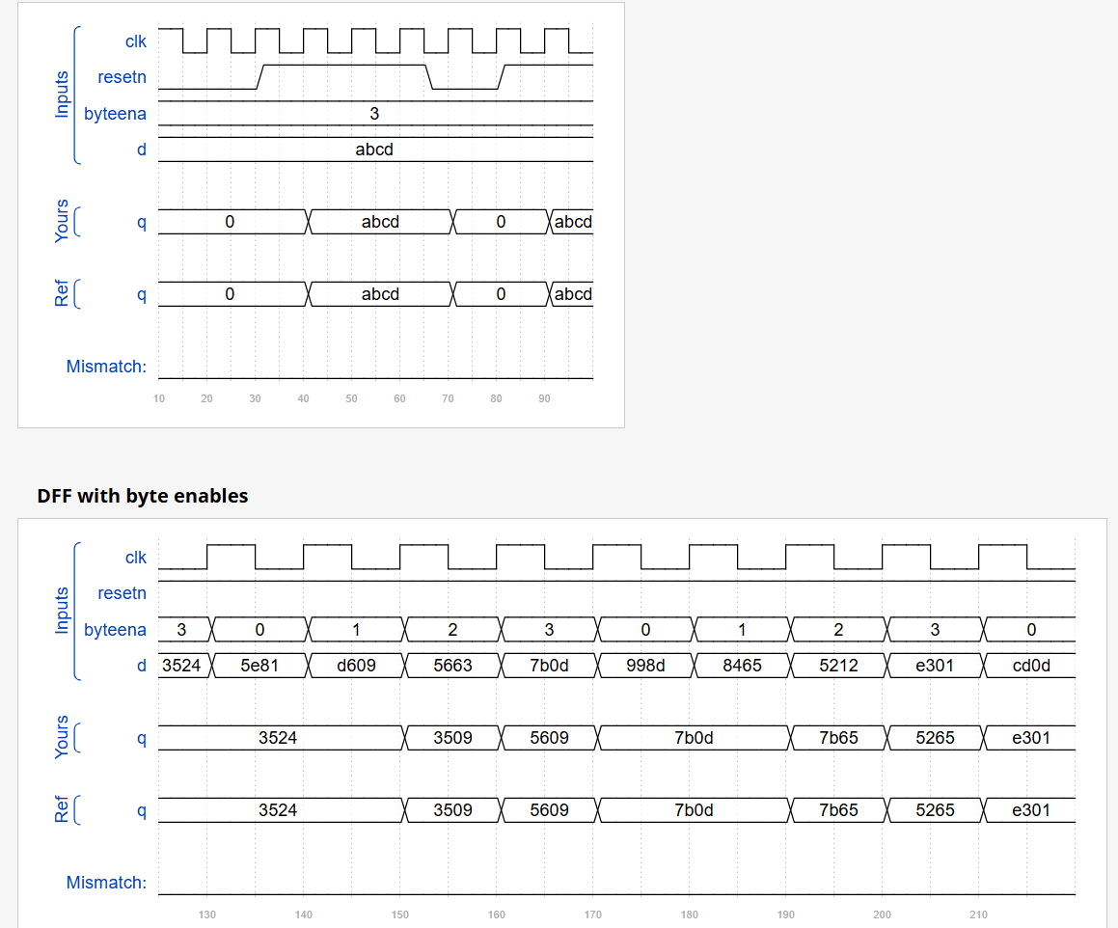

DAY:85 Exams/m2014 q4a
Problem Statement:
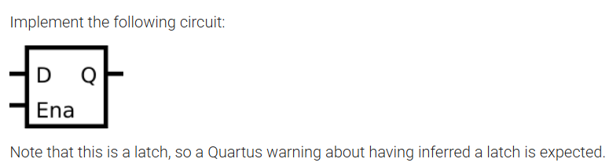
Module Declaration:
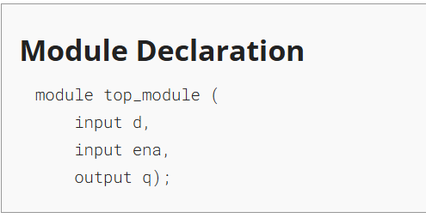
Solution:
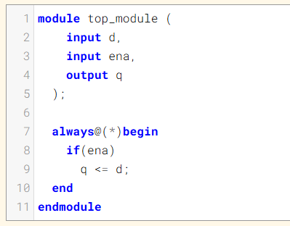

Code:
module top_module (
input d,
input ena,
output q
);

always@(*)begin
if(ena)
q <= d;
end
endmodule
DAY:86 Exams/m2014 q4b
Problem Statement:
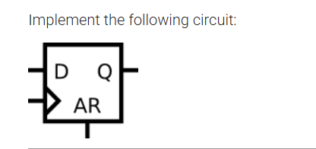
Module Declaration:
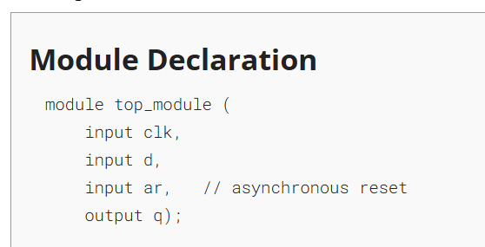
Solution:
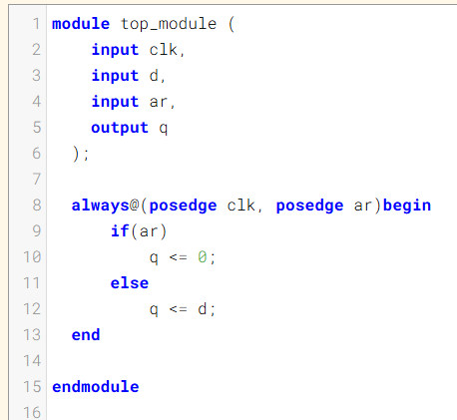
Code:
module top_module (
input clk,
input d,
input ar,
output q
);

always@(posedge clk, posedge ar)begin
if(ar)
q <= 0;
else
q <= d;
end
endmodule
DAY:87 Exams/m2014 q4c
Problem Statement:
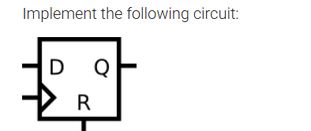
Module Declaration:
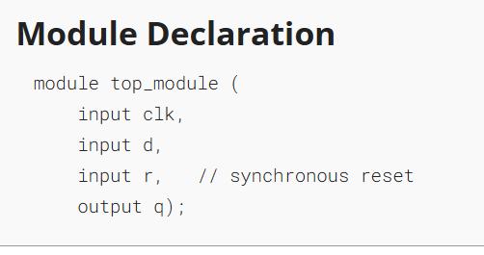

Solution:
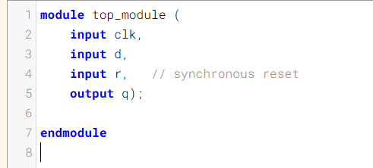
Code:
module top_module (
input clk,
input d,
input r, // synchronous reset
output q);

endmodule
DAY:88 Exams/m2014 q4d
Problem Statement:
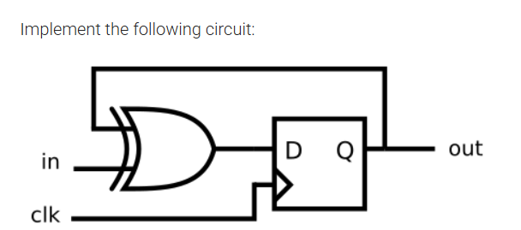
Module Declaration:
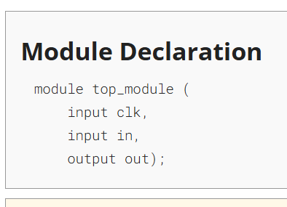
Solution:
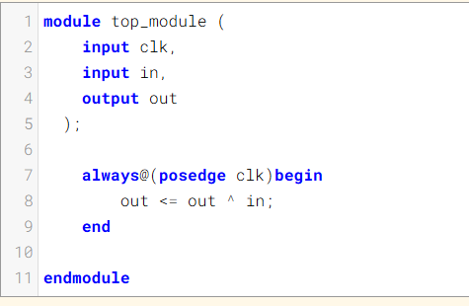
Code:
module top_module (
input clk,
input in,
output out
);

always@(posedge clk)begin
out <= out ^ in;
end

endmodule
DAY:89 Mt2015 muxdff
Problem Statement:
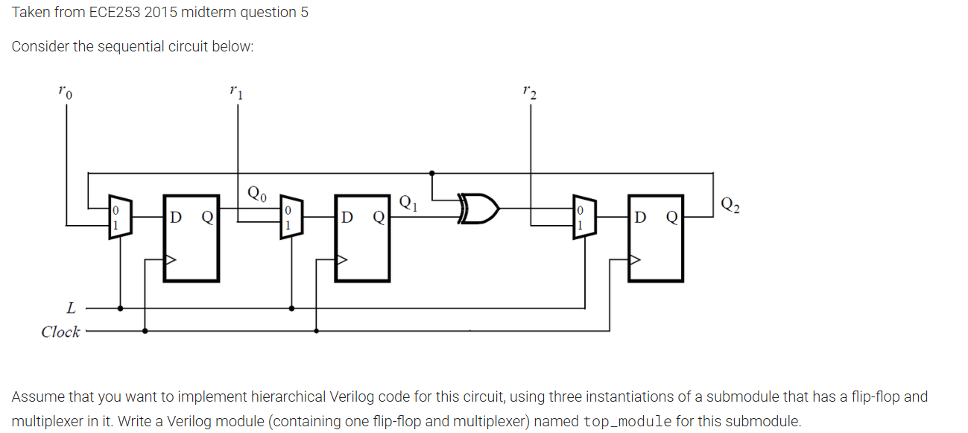
Module Declaration:
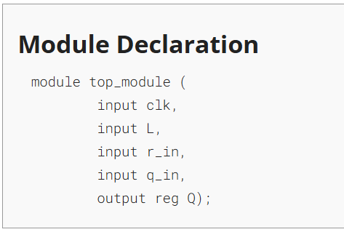
Solution:
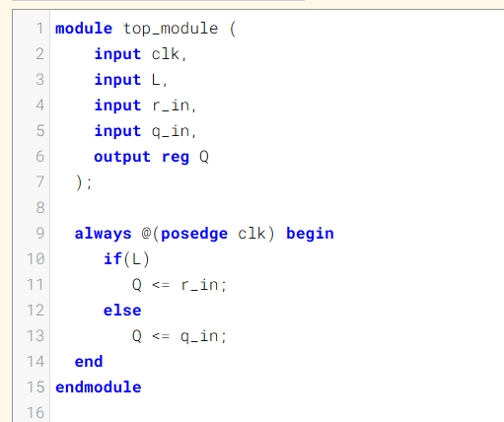

Code:
module top_module (
input clk,
input L,
input r_in,
input q_in,
output reg Q
);

always @(posedge clk) begin
if(L)
Q <= r_in;
else
Q <= q_in;
end
endmodule

DAY:90 Exams/2014 q4a
Problem Statement:
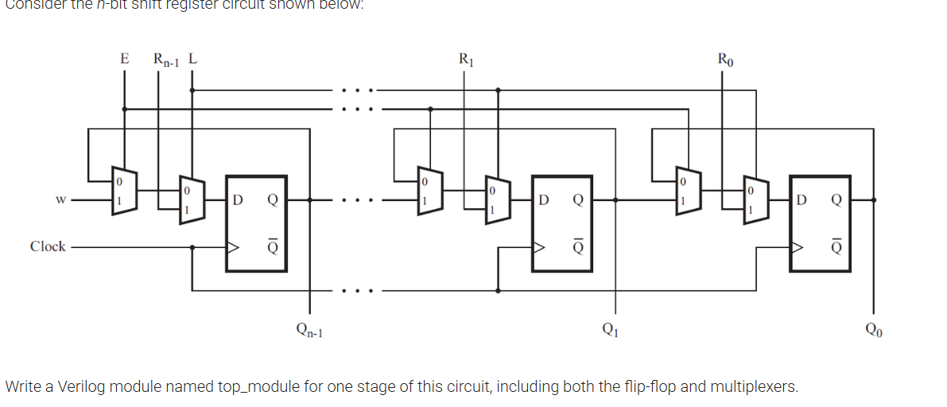
Module Declaration:
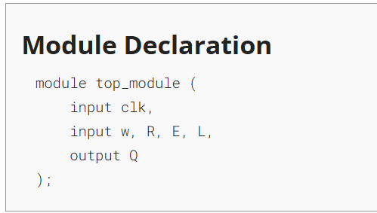
Solution:
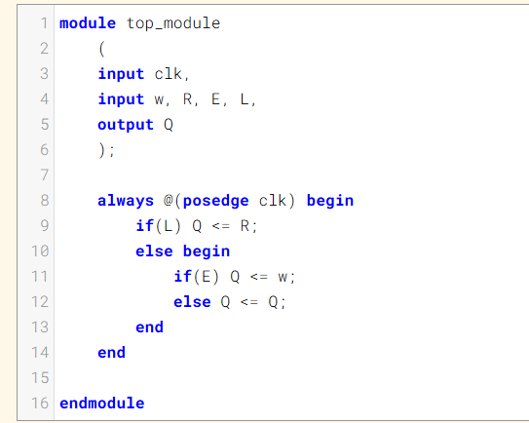

Code:
module top_module
(
input clk,
input w, R, E, L,
output Q
);

always @(posedge clk) begin
if(L) Q <= R;
else begin
if(E) Q <= w;
else Q <= Q;
end
end

endmodule



